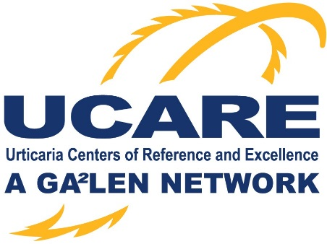

Application for a UCARE project/study

Information for applicants
UCARE projects can be applied for by individual UCAREs or several UCAREs working as a group. UCARE projects should be global projects. However, in case of special circumstances, regional/multinational projects may be supported as well. Currently, UCARE does not provide funding for projects but can help with scientific advice, UCARE office resources (communication, statistics, medical writing, ethical and regulatory issues), obtaining funding / sponsorship, and the dissemination of results. UCARE projects will be presented at GUF and UCARE meetings.

Date:

Applicant:

Name of the project:

Acronym:

Objective of the project:

Ethics approval needed/applied for?

Background of the project:

Work packages:

Duration of the project:

Scope (regional / international / global):

Financing:

UCARE Office resources needed? If so, please specify:

Communication with UCAREs:

Statistical advice (depending on funding):

Medical writing (depending on funding):

Publication strategy:

Dissemination:

